

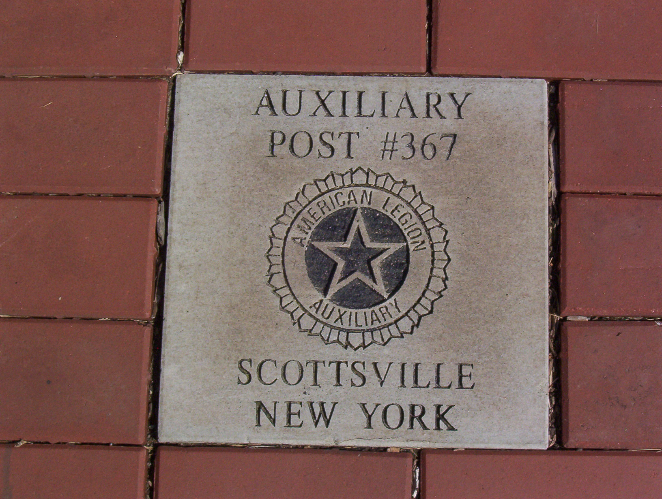

Place Name or Organization In Blocks.
One, Two, Three, Four, Five, Six, Seven, Eight or Nine lines.

Donation: $ 300.00 minimum per brick. Up to nine lines.
Not to exceed 16 characters or spaces per line.

All orders placed by March 15, will be on display by Memorial Day.

On behalf of the Memorial Park Committee, we would like to take this opportunity to thank you for placing this order. It is your contribution that will help make this park a reality.

Make checks payable to: Smith-Warren Memorial Park
Send Check and this Form To:
Smith - Warren Post No. 367, 61 Main St., Scottsville, N.Y. 14546.

Purchaser Name, Address, Phone Number:
_______________________________________________________________________
_______________________________________________________________________

